**Mini Project**

**(2020-21)**

**Mid-Term Report**



**Institute of Engineering & Technology**

**Submitted by:**

**Mani Singh (181500365)**

**Pallavi Solanki (181500445)**

**Shivendu Sharma (181500684)**

**Vikas Pandey (181500789)**

**Supervised by:**

**Harvinder Kaur**

**Department of Computer Science & Engineering**

**Contents**

**Certificates**

**Synopsis**

**Acknowledgement**

**Abstract**

**1. Introduction ---------------------------------------------- 11**

1.1 General Introduction to the topic ---------------------- **11**

1.2 Area of Computer Science -----------------------------  **13**

1.3 Hardware and Software Requirements --------------  **13**

**2. Problem definition -------------------------------------- 14**

**3. Objectives ------------------------------------------------ 15**

**4. Implementation Details -------------------------------- 16**

**5. Contribution Summary--------------------------------- 19**

**6. Project Work --------------------------------------------- 20**

**7. Future Scope** --------------------------------------------------- **52**

**8. Reference** ----------------------------------------------------------  **53**

**Certificates**

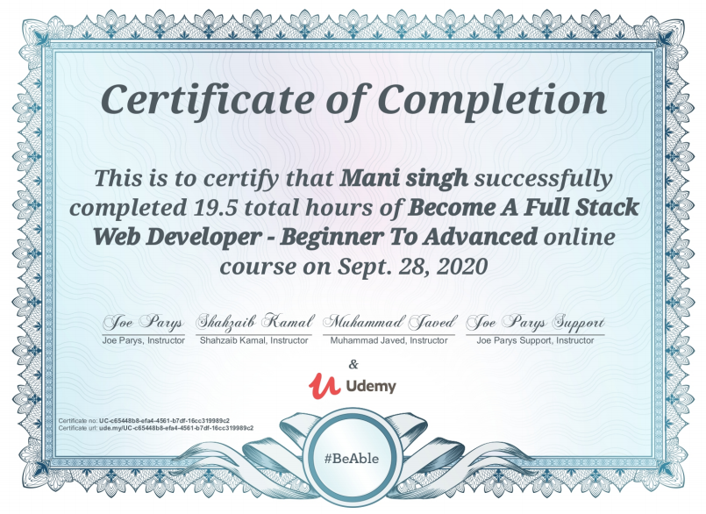

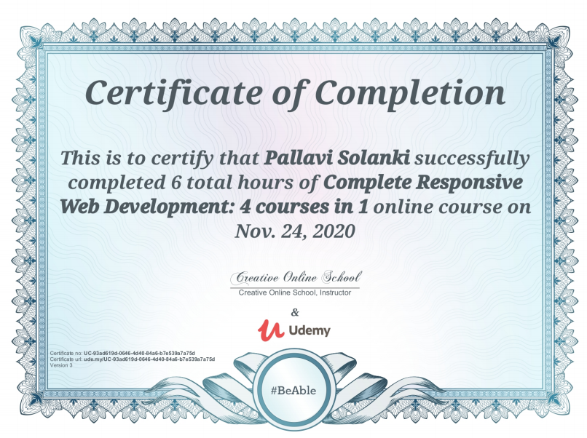

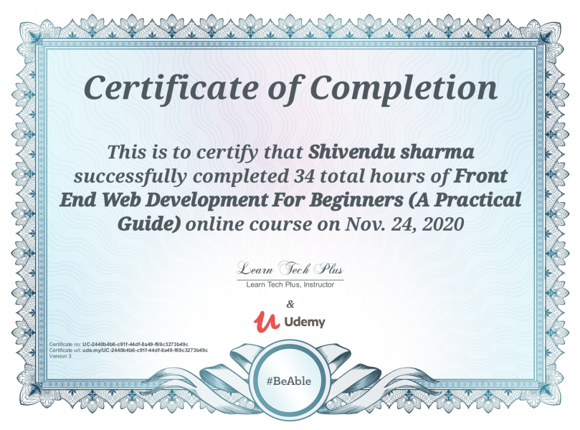

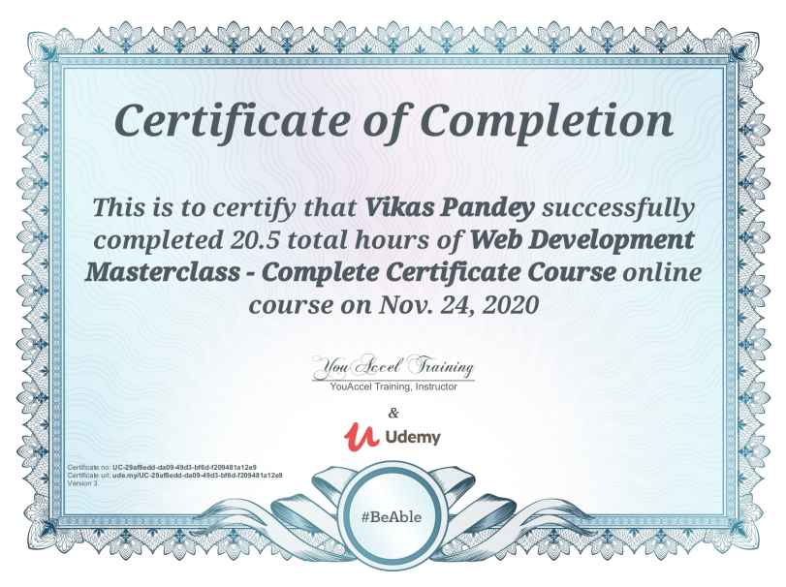

**Synopsis**

**PROJECT TOPIC: StudyHub**

**Group No. :**

**Project Group Members:**

1. Mani Singh (Sec-E./Univ Roll No.-181500365) **2.** Shivendu Sharma(Sec-F/Univ Roll No.181500684)

* Pallavi Solanki (Sec-J/Univ Roll No.-181500) **4.** Vikas Pandey (Sec-F/181500789)

**Project Supervisor:** Ms. Harvinder Kaur.

**General introduction to the topic:** StudyHub is a project that is an e-learning platform for students of B.Tech (CS). It aims to provide subject related videos, Motivational quotes and it has an inbuilt quiz for testing skills. StudyHub has all courses as far concerned to B.Tech Students. Its quizzes and Motivational quotes keep on shuffling.

**Area of computer Science:** StudyHub is a fully online website that falls under the domain of e-learning. Web-Development is the environment this project has been developed into.

**Hardware and Software requirements:**

* **Hardware Requirements:** 1GB RAM (min.), Laptop/Desktop, External Backup Storage.
* **Software Requirements:** Brackets HTML editor, Web browser, Graphic Editor, FTP client (FileZilla), GitHub, internet connection.

**Problem Definition:** The problem that has led us to work on this project is easy availability of study material at a single platform without any hustle. This site will gather resources from different sources on WEB and make it available on a single platform.

**Objective:**

Objective of this website is to help student learn more and effectively from the resources on the internet. What it does for you is it collects the best material available on certain topics which contain lecture/e-learning videos, practice sheets and accumulates all at a single place so an individual could use it effectively.

**Methodology:**

StudyHub being a **website** uses HTML, CSS, BOOTSTRAP, jQuery libraries, free host services, CANVA (logos) for front-end and PHP and MySQL for back-end.

**Implementation details:**

The webpage uses HTML and Cascading Style Sheet for its front-end structure. Bootstrap and jQuery are used to make it responsive and add certain animations and hover, click effects. CSS cards are designed to display daily motivation quotes and useful tips.

Back-end will use PHP and MySQL as a database to store login details.

**Contribution Summary:** Mani and Pallavi have together developed the login and registration page. All effects, animations and logos have been arranged solely by them.

Vikas has developed the Home-Page with all animations, effects and logos used in it.

Shivendu has made the navigation bar of the Home-Page and will be working on back-end.

**Progress till date:**

Home-page and Login page along with a separate page of registration has been developed although finishing front link connections and finishing works are pending in front-end development.

Back-end development has not started yet.

**Signature of Project Guide: _______________________**

**Acknowledgement**

We have given efforts in this project. However, it would have been possible without the kind of support and help of many individuals and organizations.

We would like to give special thanks to our instructor Harvinder Kaur for guiding, supporting and for her constant encouragement from this project.

We would like to express my gratitude towards our parents & member of GLA University for their kind co-operation and encouragement which help us in completion of this project.

**Abstract**

In this project we will build a E-learning website name StudyHub (The resources you need). This is a website which is design to help, support and enable B.Tech students of a specific stage to overcome their resistance and fear. The website limits not only up to internet but also it provides an admirable way to learn distinct stuff. This website consists video lecture, Quizzes and motivational quotation which help students to keep motivating towards their studies. This project mainly the development of a fully responsive, compatible, intuitive and interactive website. The project comprises of both front-end and back-end and it can store data and login details of its user once it is complete. This project is made in domain of web-development to make it available for each individual steadily and is only one search away.

**Introduction**

**1.1 General Introduction to the topic**

To build a StudyHub website we use all basic components which are required for web-development project. The web page uses HTML, Cascading Style Sheet (CSS) for its front-end structure. Bootstrap and j-query are used to make it responsive and certain animation and hover, click effects. CSS cards are design to display daily motivational quotes and useful tips.

Back-end of the website required all the basic tools and languages of back-end development. PHP and My- Sql database are the two major component. It can store data and login details of its user once registration is done.

**About StudyHub**

StudyHub is a project that is an e-learning platform for students of B.tech. This website delivers a wide selection of online courses for Btech students via the internet. It is very economical place to learn.

It aims to provide subject related videos; Motivational quotation and it has an inbuild quiz for testing skills. Its quizzes and motivational quotes keep on shuffling. StudyHub has all courses as far concerned to B.tech students.

**How it works and useful**

* This website consists of all the material (courses/subjects) which is require for B.Tech students.
* As it provides the Video lectures for all Subjects of B.Tech which help students in intuitive learning.
* This website consists of quizzes that will enhance the student confidence and check their learning skills.
* The website requires to register to reach the following website material.
* It provides a free resource access for learning in intuitive way.

**Basic ER Diagram**

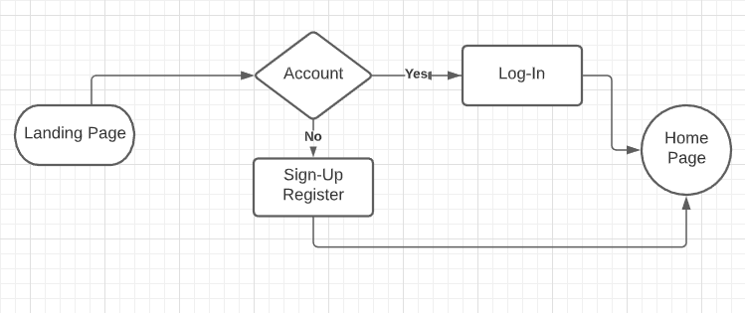

**1.2 Area of Computer Science**

StudyHub is a project that falls under Computer science, in domain of web-development. This project is mainly the development of a fully responsive, compatible, easy to use, and interactive website. The project comprises of both front-end and back-end of the website and it can store data and login details of its users once it is complete.

StudyHub is built keeping in mind that it would have many users who won’t be able to access this website all the time from their laptops or desktops, hence, this site is made fully responsive for their users and can be accessed from any device which have minimal and basic requirements.

This project is made in domain of web-development to make it available for each individual easily and is only one search away.

**1.3 Hardware Requirements**

* 1 GB RAM
* Laptop/Desktop
* External Backup Storage
* Internet Connection (Ethernet/Mobile Network)

**1.3** **Software Requirements**

* Brackets text editor (HTML text editor)
* WEB Browser (Chrome, web explorer)
* Graphic Editor (GIMP)
* FTP client (FileZilla)
* GitHub (progress report)

**Problem definition**

The problem that has lead to us to work on this project is easy availability of study material at single platform without any hustle. This site will gather resource with different sources on WEB and make it available at single platform. The problem seems to be complicated but it can be resolved if one gets all the material he requires for his subject and study purposes. With all the resources and a bit of motivation one can do miracles. Students now a days prefer to get their problems solved online rather than meeting someone face-to-face OR in-person. StudyHub focuses on this problem of modern world students and its main aim is to solve this problem. So, to this this problem we create a website where students easily access the resources they need.

**Objective**

The objective of this website is to help students in learn more and effectively from the resources of this website through internet. It consists the best material available on certain topics which contain lecture and e-learning videos, practice sheet all accumulate at a single place so an individual can use it intuitively. This is the only way to test the skill and level of the students and help us in providing them better stuffs according to their capturing ability.

**Implementation Details**

**Use case Diagram**

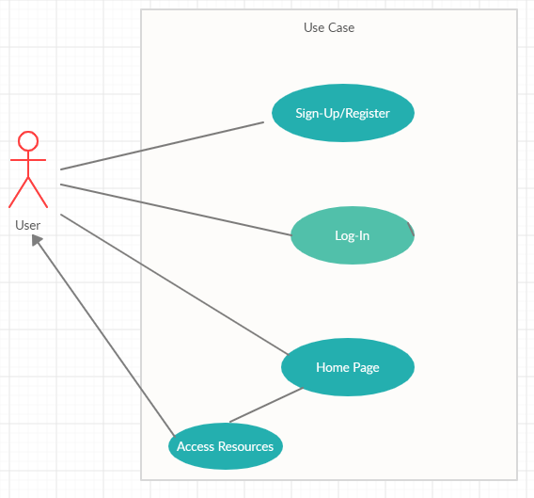

StudyHub is a website that uses all the basic components used by a website. To make it more user-friendly certain libraries and tools have been implemented.

**HTML**

The language provides the basic structure to the page. HTML rows and tables, containers,etc.

HTML tags , nested tables have also been used to benefit in less lines of code and ease of implementation

**CSS**

CSS divisions, nested divisions, margins, animations, and development of logos.

Animations and effects added to the page. The styling and spacing to the page, colour and texture. Cascading Style Sheet’s divisions, containers, nested divisions, margins etc. has been implemented to make the front end look interactive. The colour combination and texture that uses up the CSS libraries helps differentiate the text on the website and remain readable.

CSS margins, spacing and padding made the website available at the centre of the screen and blocked/hidden corners were minimized.

CSS text-decoration, font-family, font-colour, z-index etc. has also been implemented so to distinguish between the text and background.

**BOOTSTRAP**

Bootstrap libraries have been imported to the code in order to get responsiveness in the website.

Few of the Imported libraries are-

<https://stackpath.bootstrapcdn.com/bootstrap/4.5.2/css/bootstrap.min.css>

<https://stackpath.bootstrapcdn.com/bootstrap/4.5.2/js/bootstrap.min.js>

<https://stackpath.bootstrapcdn.com/font-awesome/4.7.0/css/font-awesome.min.css>

These libraries contain bootstrap.min css that helps making the margins and spacing expand and shrink according to the screen.

The bootstrap JS has been used to import some libraries of the java-script that has made to sort our content, loop, terminate, etc wherever required.

**J-Query**

Libraries of J-Query have been imported and implemented in order to give certain animations to the site. J-Query libraries provided certain animations to the buttons, hover effects, animations, hover effects, on-click animations etc. that has made the website more interactive and attractive.

One of the libraries is mentioned-

<https://code.jquery.com/jquery-3.5.1.slim.min.js>

J-Query makes the implementation of JavaScript easy and it is one of the reasons to use it in this site.

**LOGO / IMAGES / ICONS**

The logos used in this site have been custom created by CANVA and proper copyrights and credits have been kept in light.

Images have been taken either from google pictures or have been downloaded from bing (png is the only format used).

Icons in the sites have been taken from the source sites and legal use of icons have been followed.

**BACK-END**

This is the future of this website; it will use MySQL and PHP for Back-End development.

**HOSTING**

Free Hosting service provider is to be used to host this site on the internet.

A specific domain isn’t decided yet but hosting is to done on a free platform only.

**Contribution Summary**

Pallavi has developed the login and registration page. All effects, animations and logos have been arranged by her.

Vikas has developed the Home-Page with all animations, effects and logos used in it.

Mani has developed the contact us page. All effects, animations and logos have been arranged by her and worked on back-end of signup.

Shivendu has made the navigation bar and about us page. All effects, animations and logos have been by arranged him.

**Project Work**

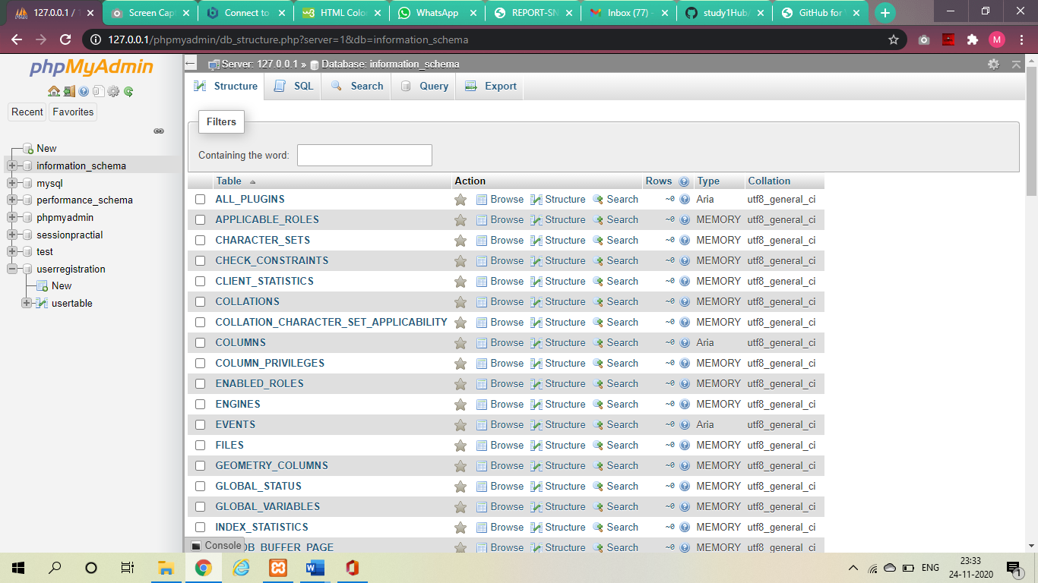

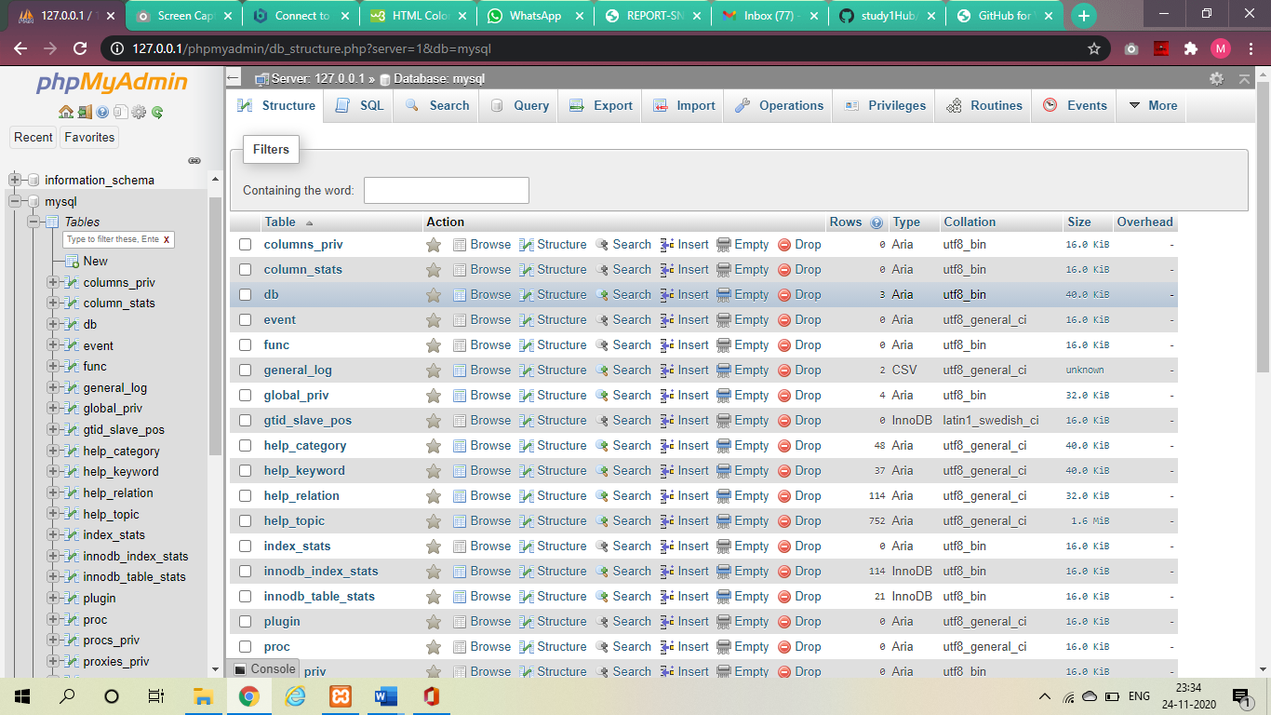

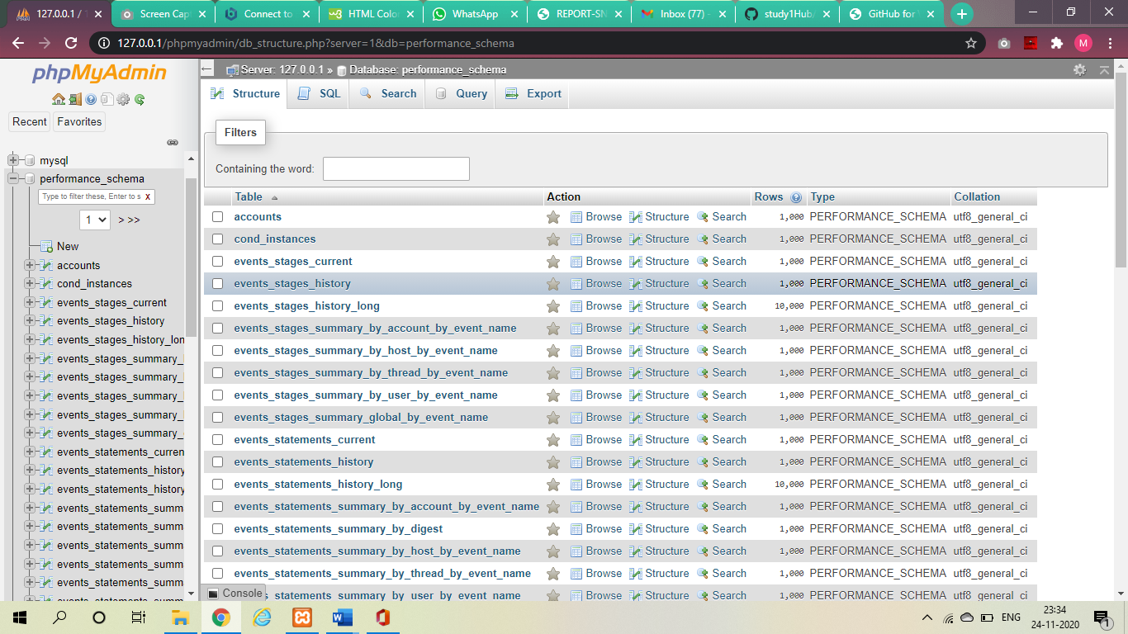

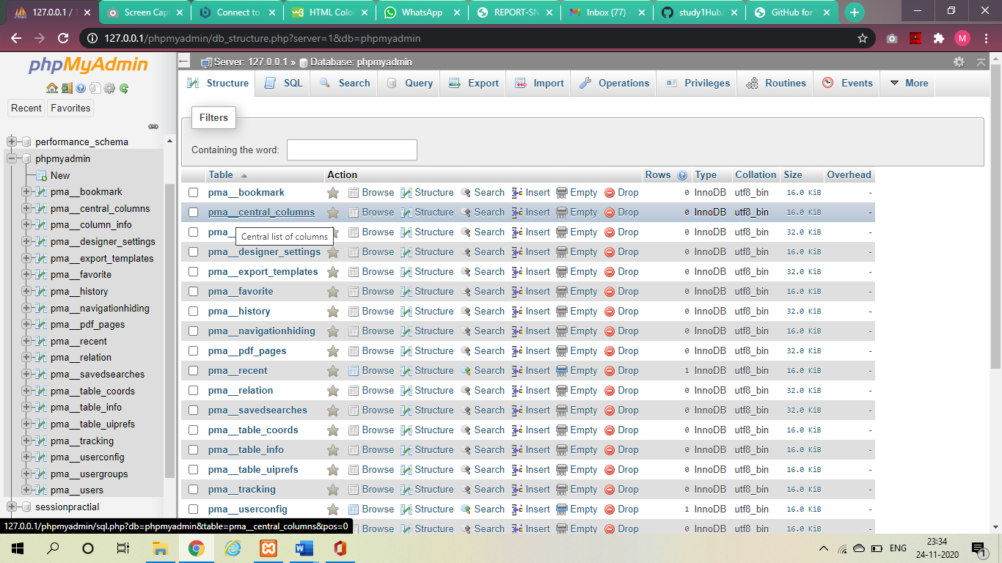

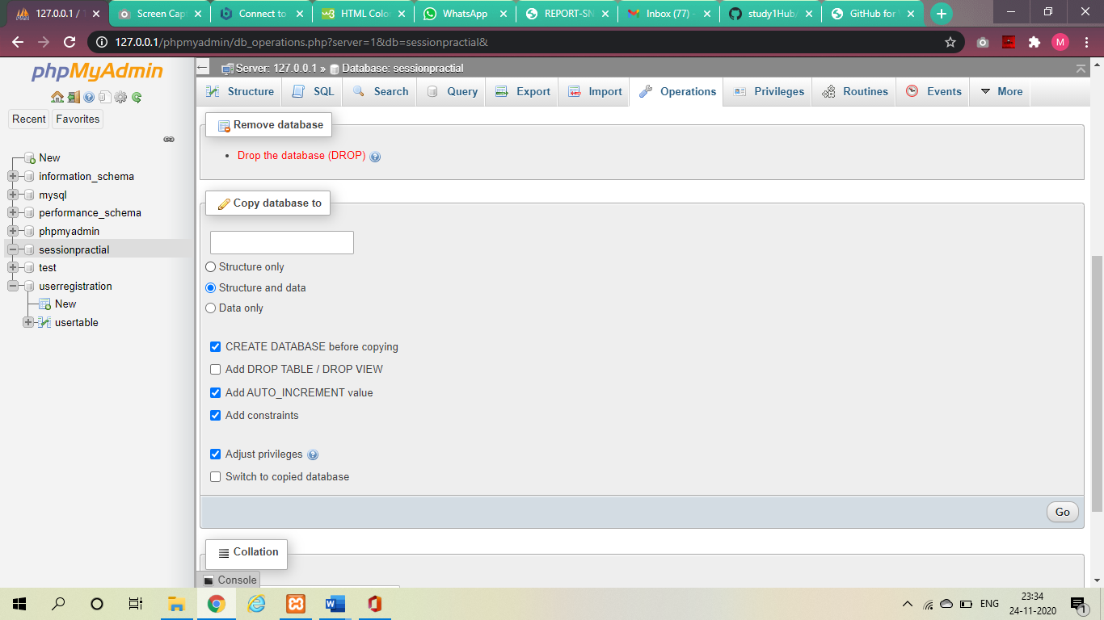

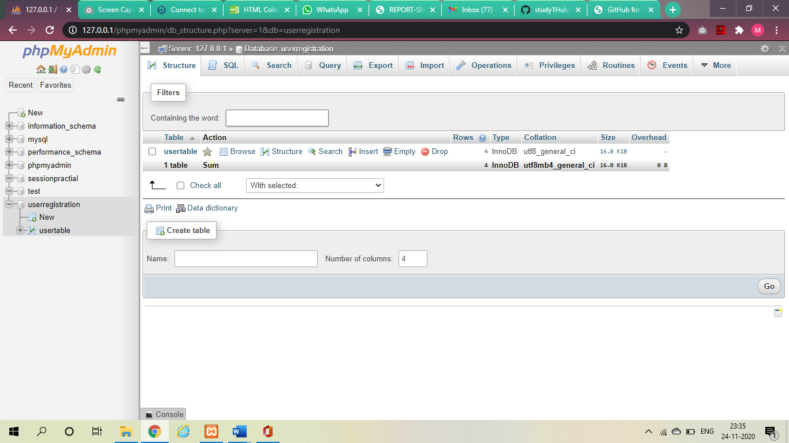

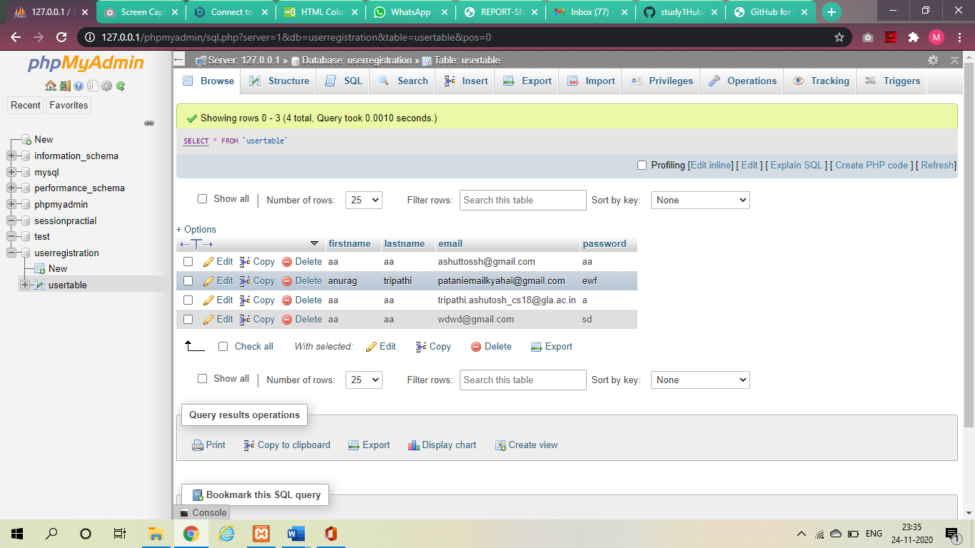

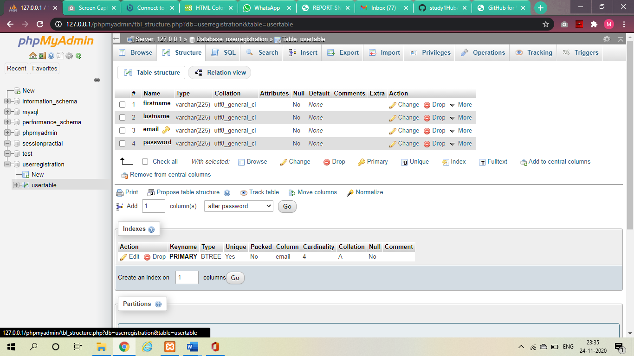



.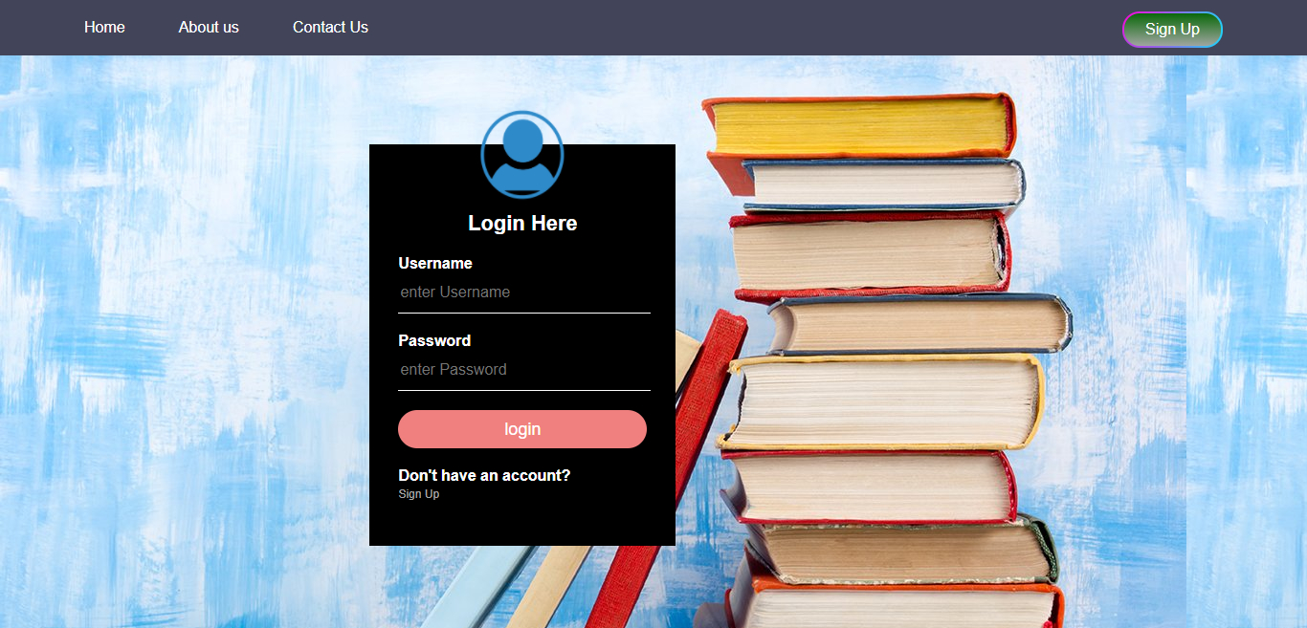

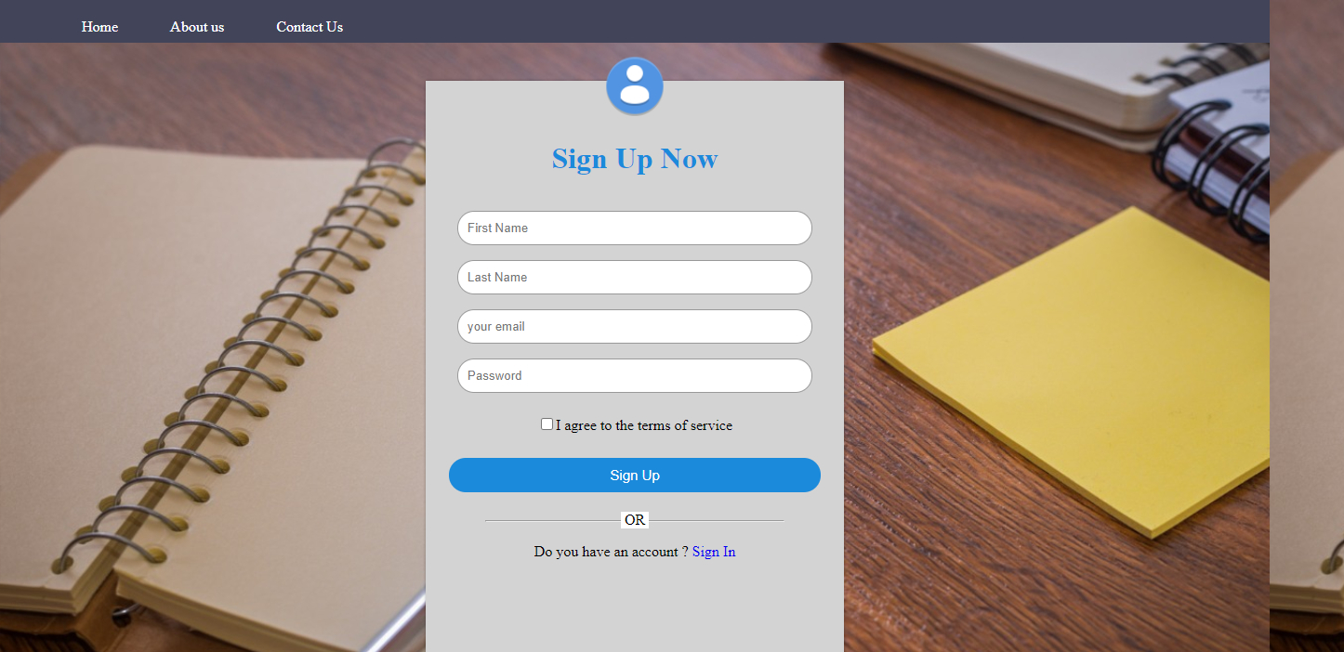

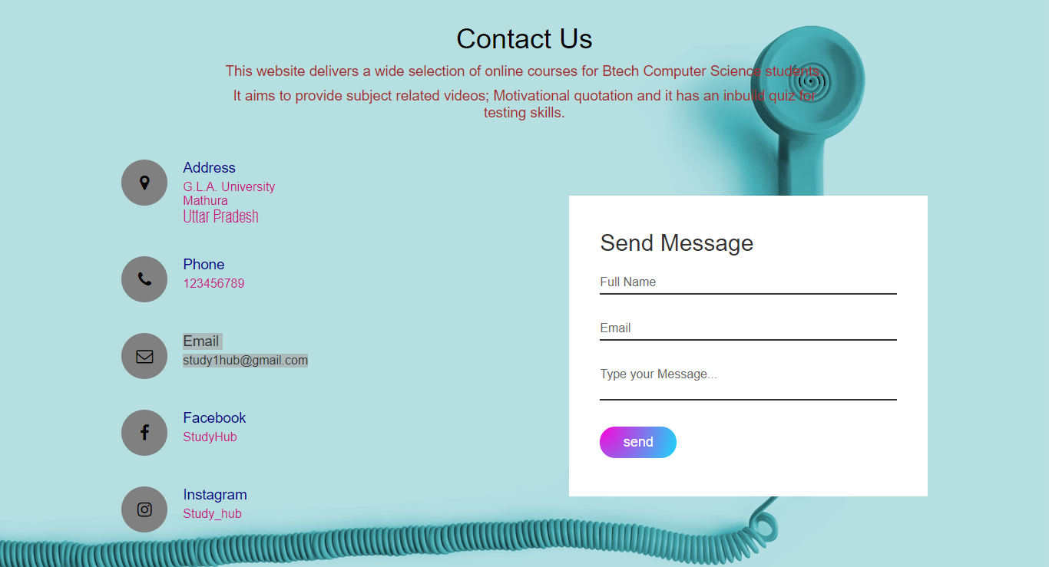

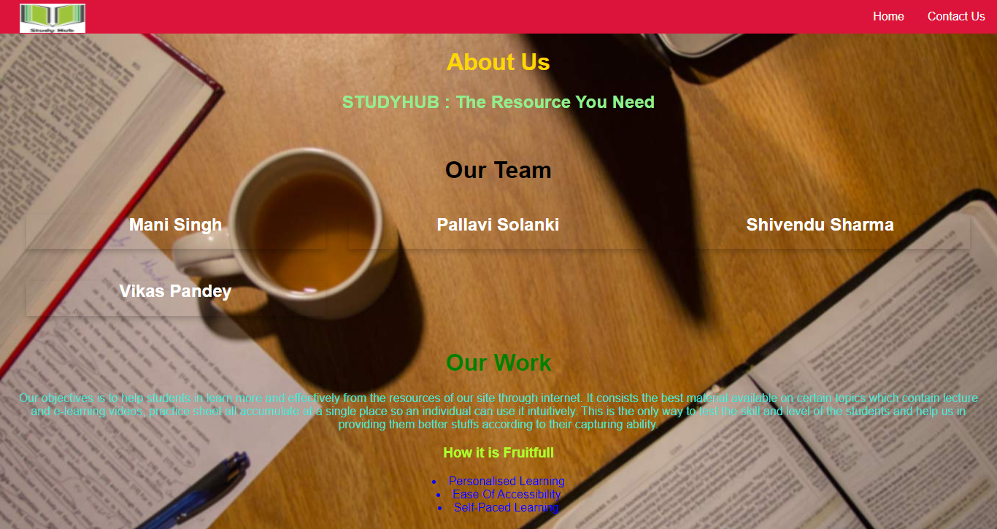

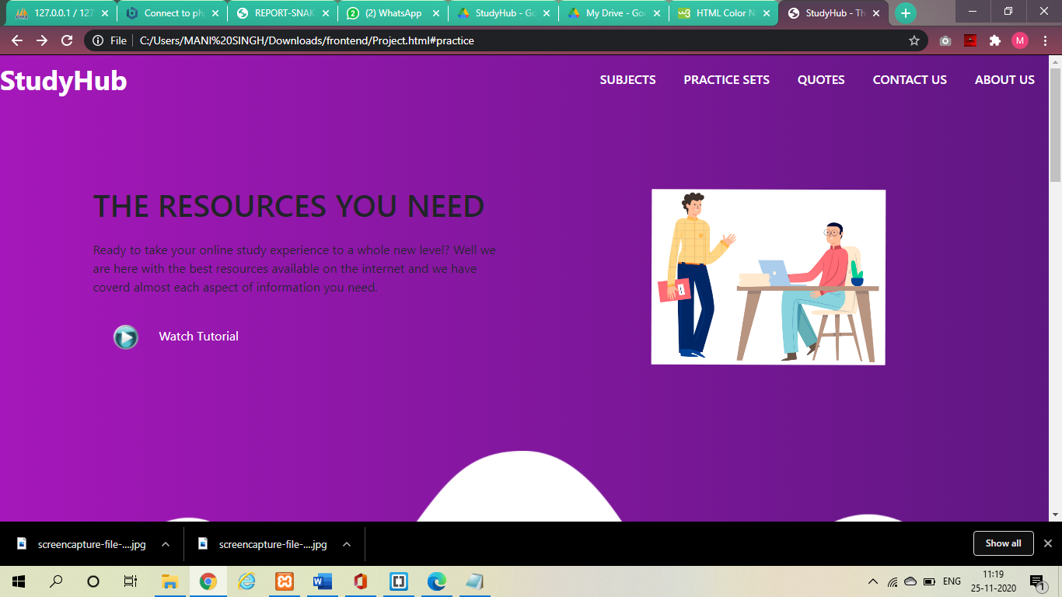

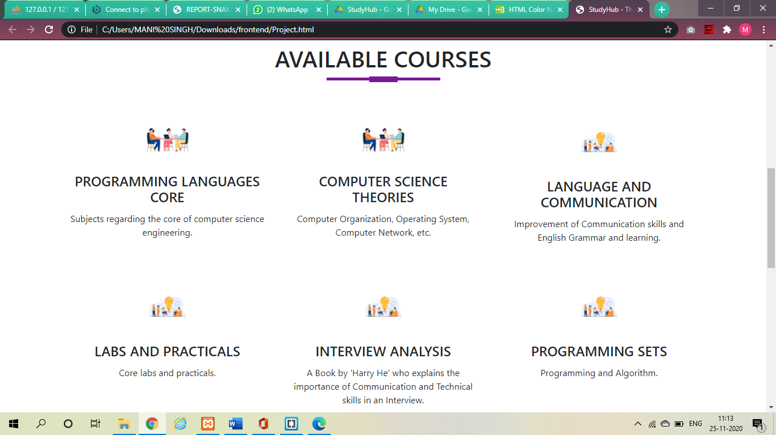

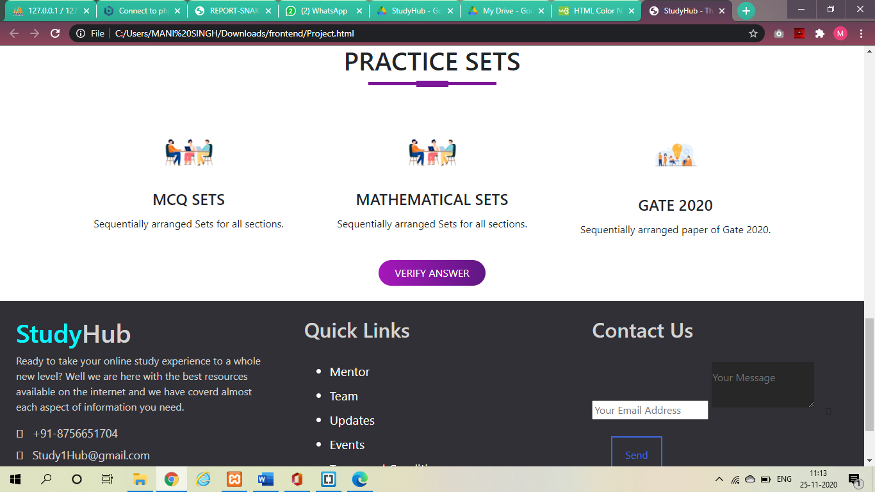

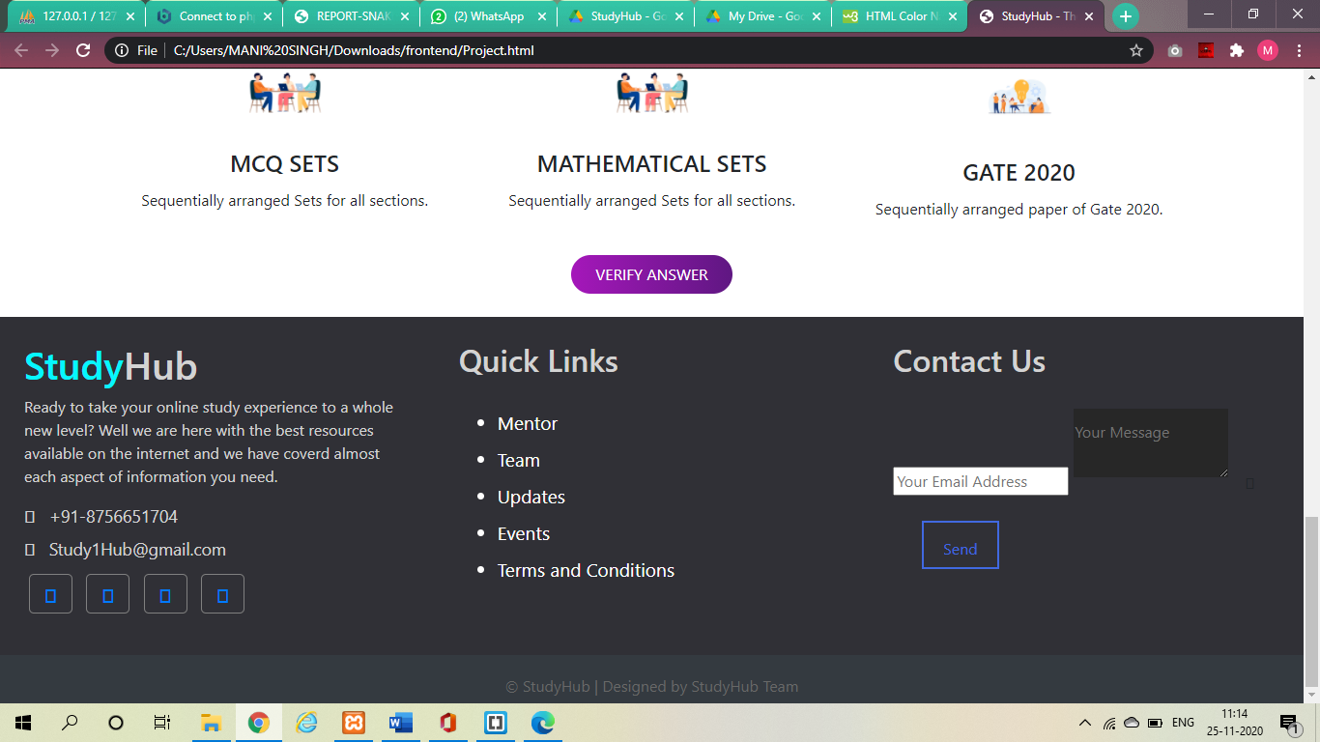

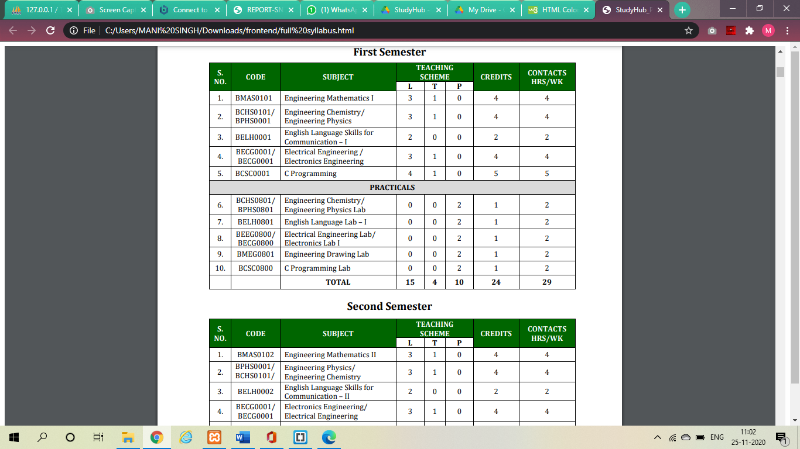

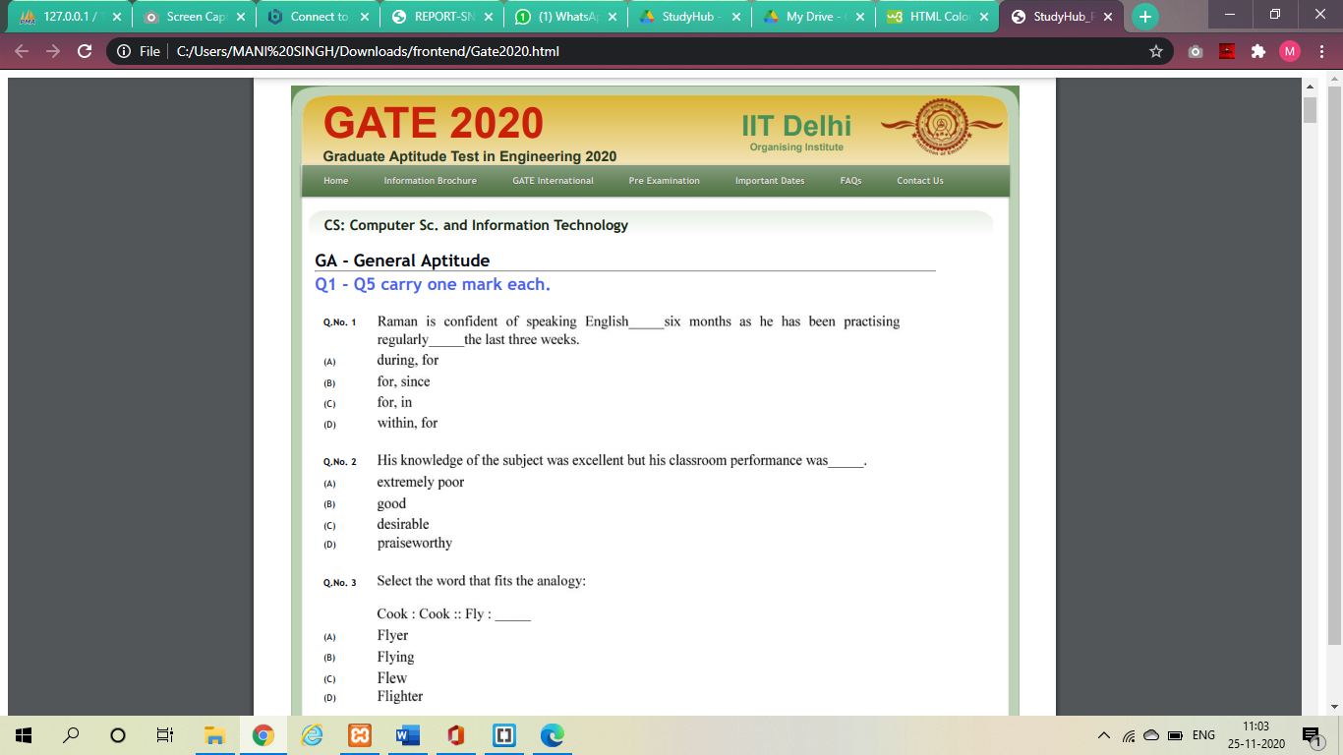

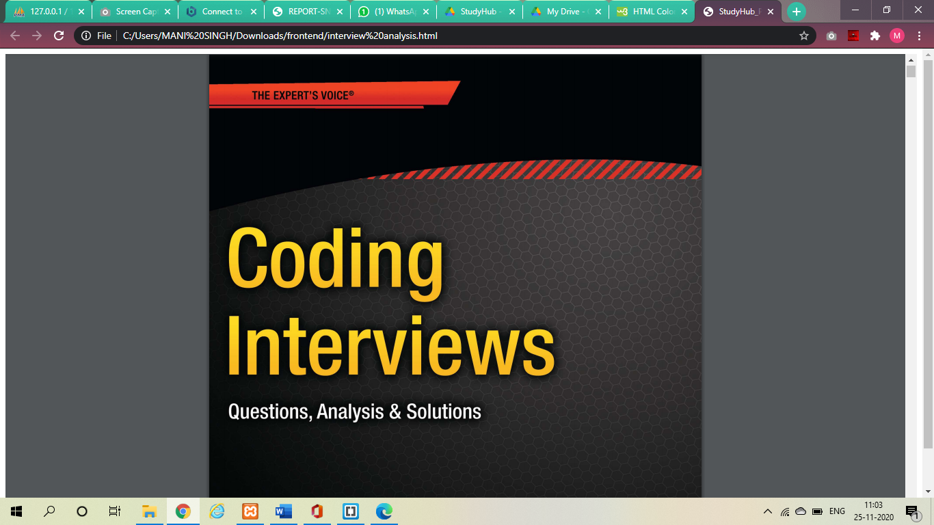

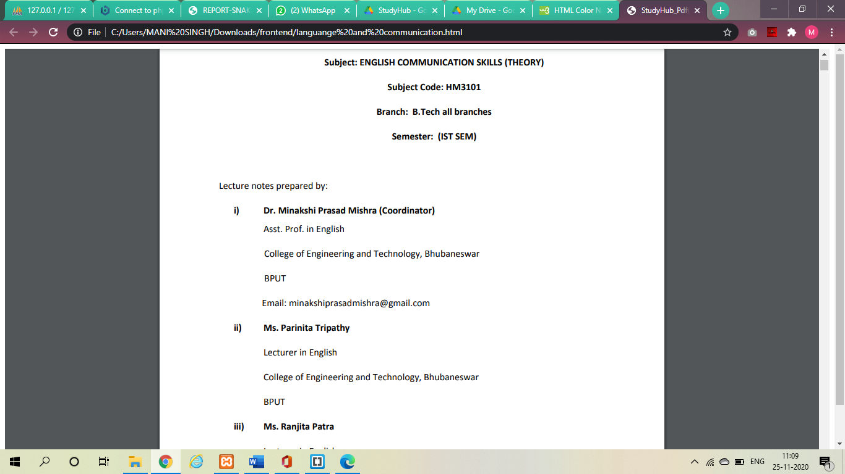

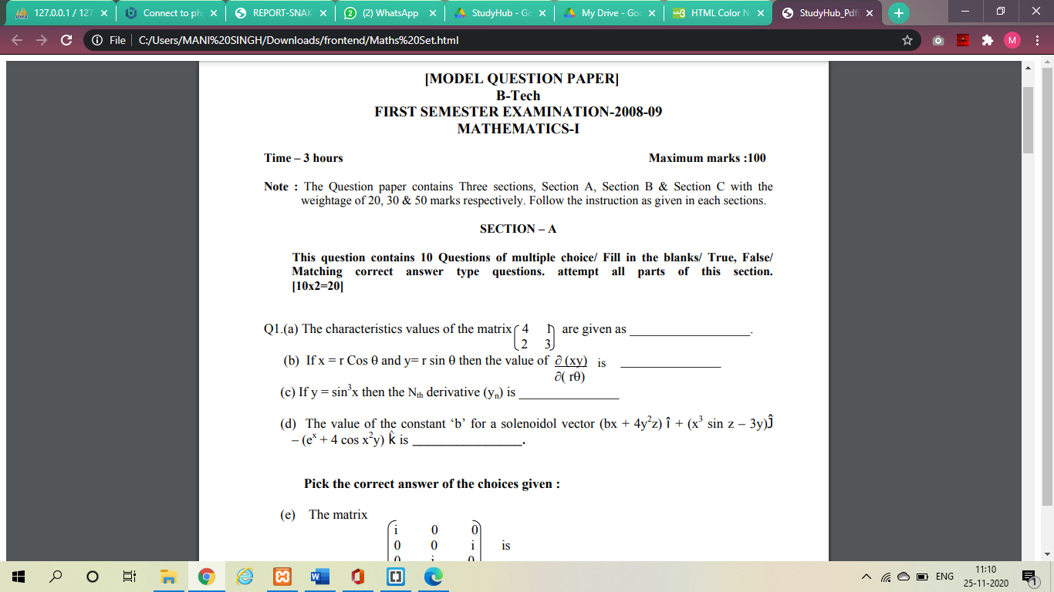

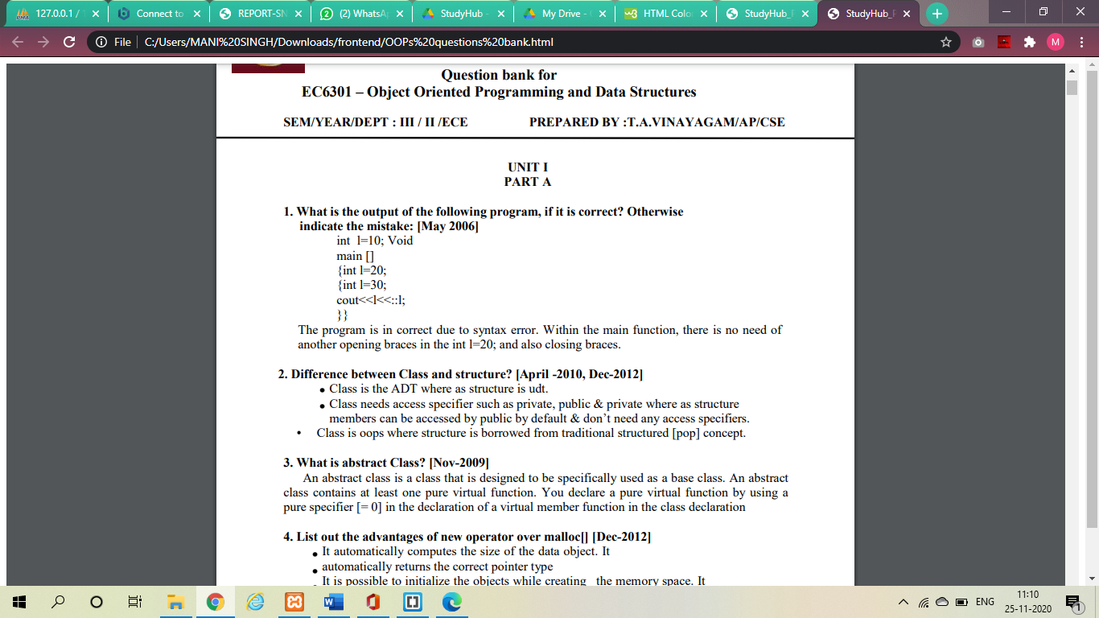

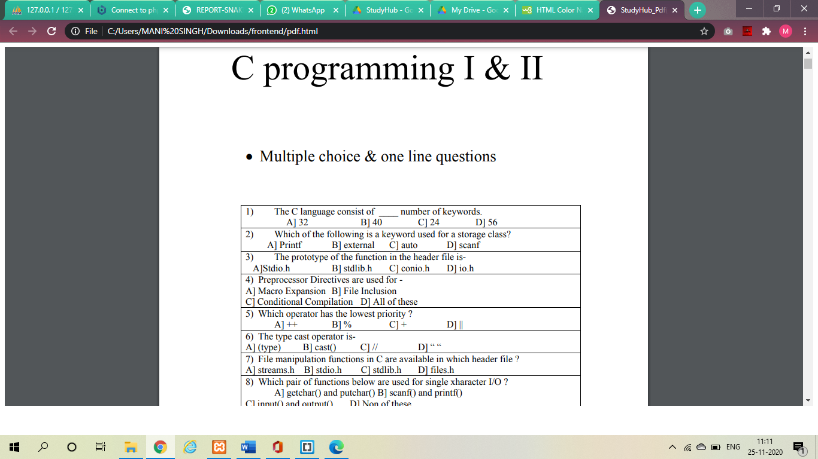

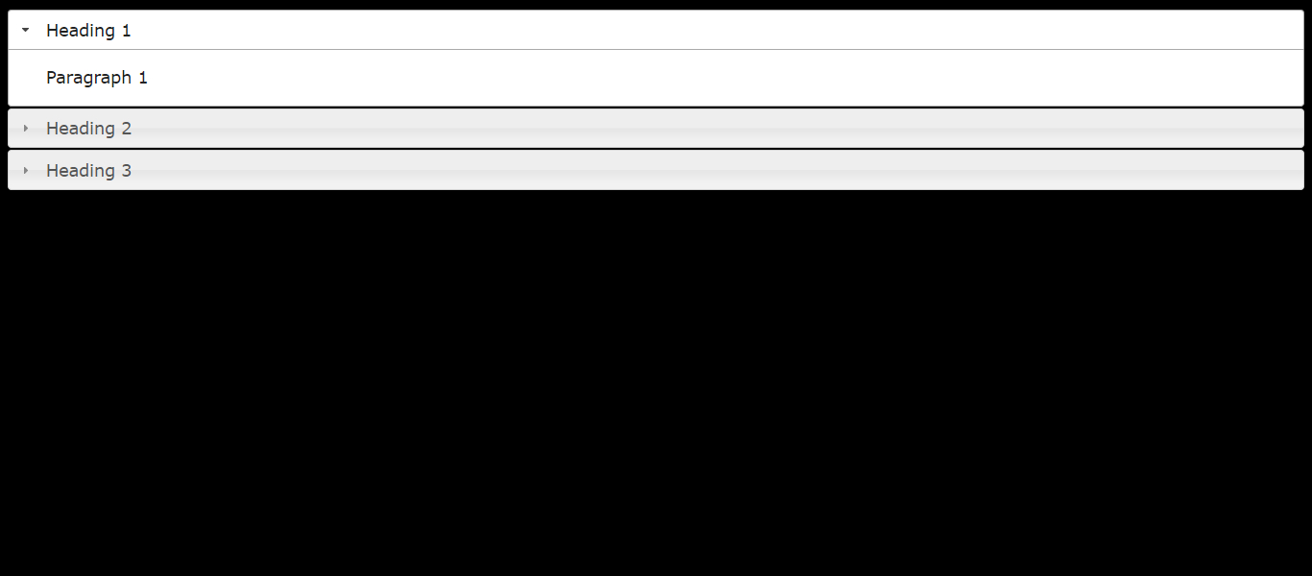

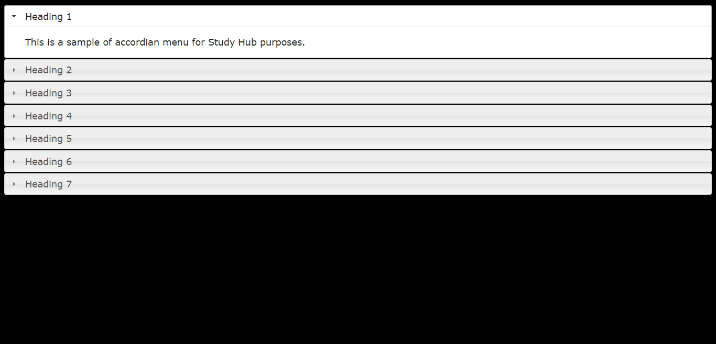

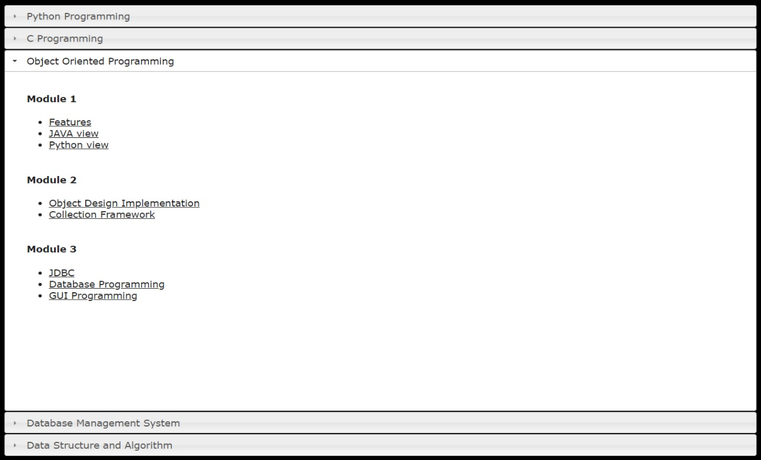

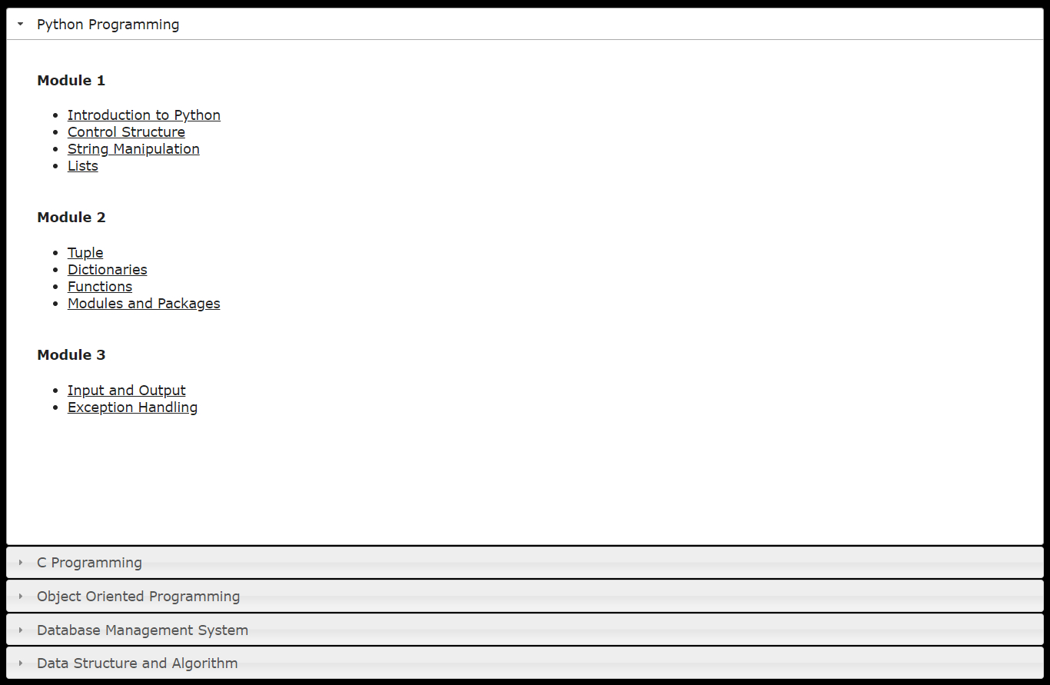

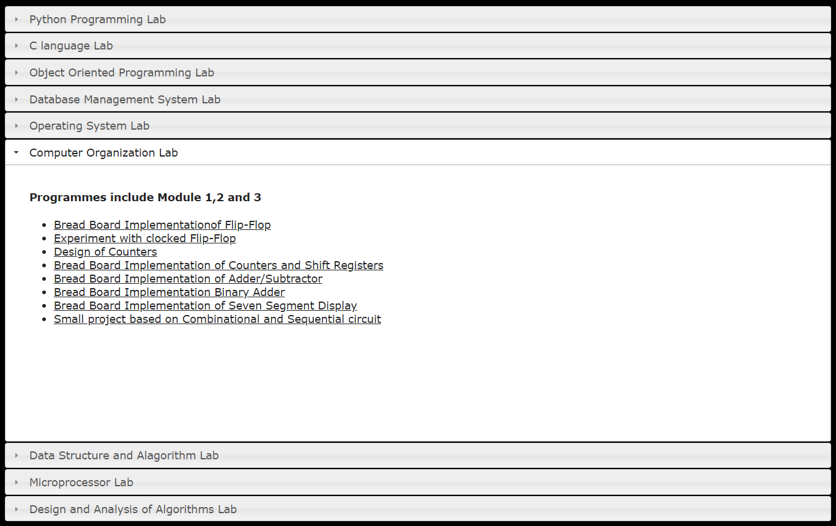



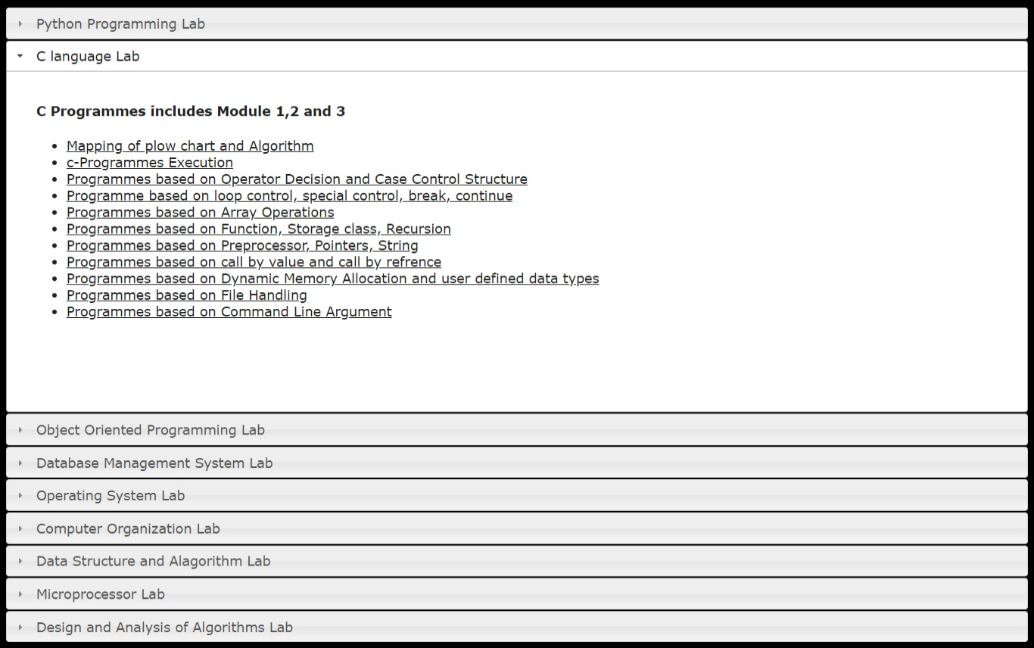

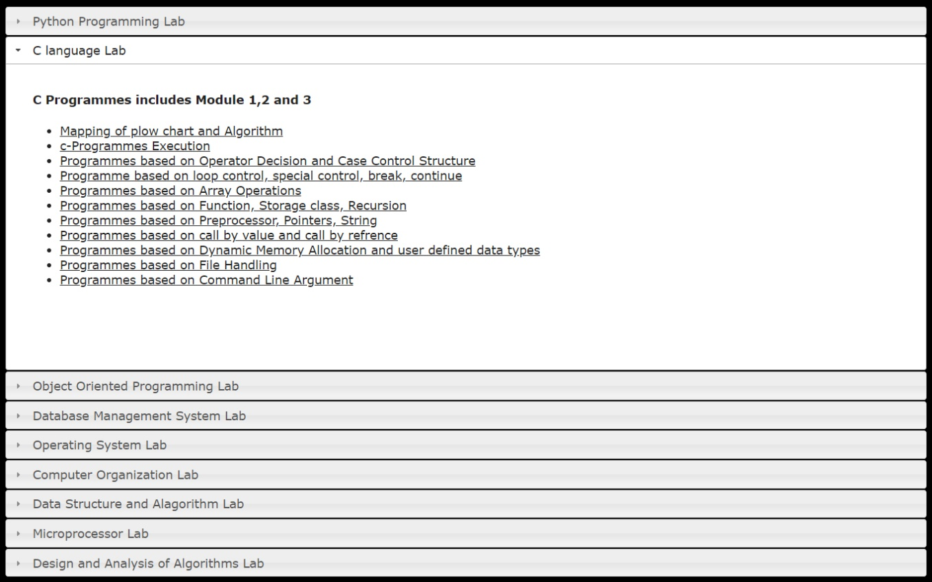

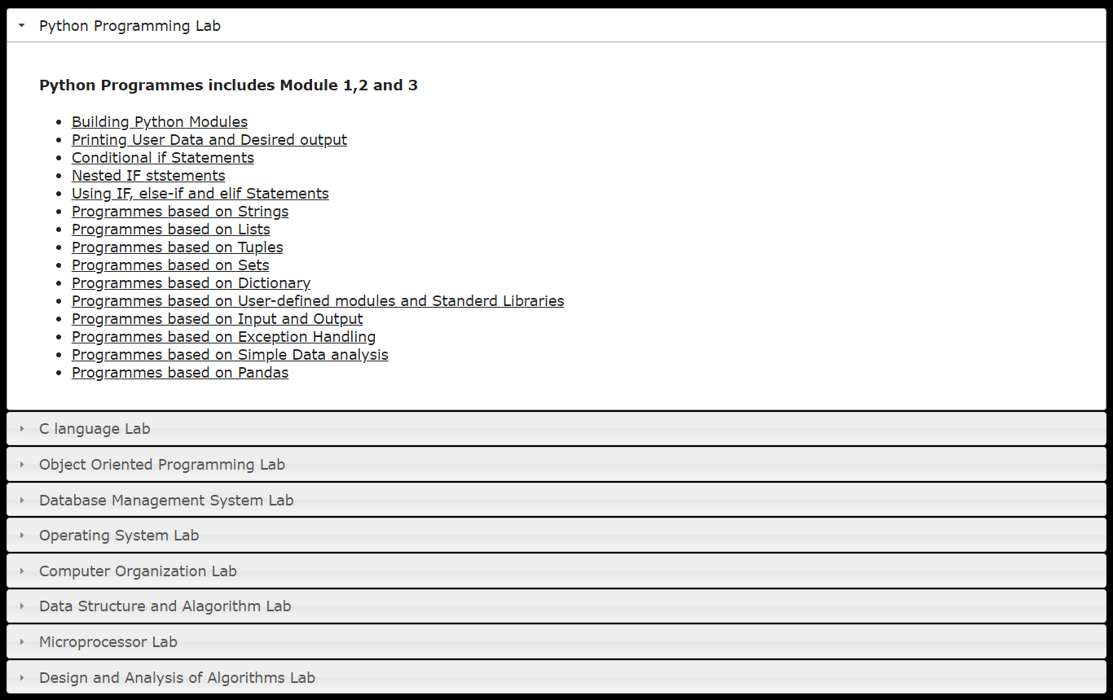

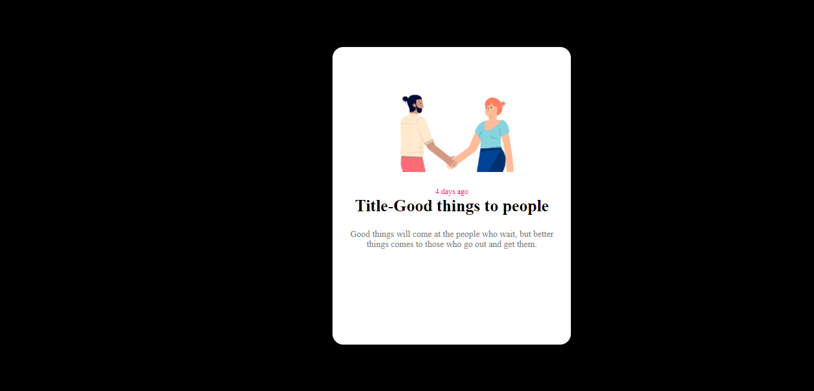

**Future Scope**

Study hub is to help student learn more and effectively from the resources on the internet. What it does for you is it collects the best material available on certain topics which contain lecture/e-learning videos, practice sheets and accumulates all at a single place so an individual could use it effectively.

**Reference**

Websites from which we take help from:

* [**https://www.udemy.com/**](https://www.udemy.com/)
* [**https://www.w3schools.com/**](https://www.w3schools.com/)
* [**https://www.codecademy.com/**](https://www.codecademy.com/)
* [**https://www.youtube.com/**](https://www.youtube.com/)

**Books:**

* **HTML & CSS, and JavaScript & JQuery by Jon Ducket**
* **JavaScript and JQuery: Interactive Front-End Web Development, by Jon Duckett**